# Logo Description automatically generatedLogo Description automatically generated FOOD WASTE REDUCTION MANAGEMENT

## PRODUCT DEVELOPMENT LABORATORY(19IT67C)

***Submitted by***

|  |  |
| --- | --- |
| **DIVYA G** | **2015001** |

***in partial fulfillment of the award of the degree***

***of***

**BACHELOR OF TECHNOLOGY**

## in

**INFORMATION TECHNOLOGY**

## NATIONAL ENGINEERING COLLEGE, KOVILPATTI-628 503

**ANNA UNIVERSITY: CHENNAI 600 025**

**APRIL 2023**

# ANNA UNIVERSITY: CHENNAI 600 025 BONAFIDE CERTIFICATE

Certified that this Product Development laboratory report “**FOOD WASTE REDUCTION MANAGEMENT**” is the bonafide work of **“DIVYA G (2015001)”** who carried out the product development under my supervision.

|  |  |
| --- | --- |
| **SIGNATURE** | **SIGNATURE** |
| **Mrs.G.Ramya, M.Tech.,** | **Dr.S.Rajagopal, M.E., Ph.D.,** |
| **Supervisor** | **Project Coordinator** |
| Assistant Professor | Assistant Professor(SG) |
| Department of Information Technology | Department of Information Technology |
| National Engineering College | National Engineering College |
| K.R.Nagar, Kovilpatti–628503 | K.R.Nagar, Kovilpatti–628503 |
| Thoothukudi District, TamilNadu | Thoothukudi District, TamilNadu |

*Submitted for the product development laboratory viva voce examination held at National Engineering College, K.R Nagar, Kovilpatti – 628503 on*

*…………………*

## INTERNAL EXAMINER EXTERNAL EXAMINER

**ACKNOWLEDGEMENT**

First and foremost, we would like to thank God Almighty for showering his blessings throughout our life. He has been the tower of our strength in each step of our work. We take the privilege to express hearty thanks to our parents for their valuable support and effort to complete the project work.

I would like to express our deep sense of gratitude and respectful regards to our director **Dr.S.Shanmugavel, B.Sc., D.M.I.T., Ph.D.,** for giving an opportunity to do this work.

I would like to express our deep sense of gratitude and respectful regards to our principal **Dr.K.Kalidasa Murugavel, M.E., Ph.D.,** for giving an opportunity to do this work.

I express our profound thanks to our beloved Head of the Department **Dr.K.G.Srinivasagan, M.E., Ph.D.,** for extending his full support and providing various facilities during the project work.

I would like to extend our profound thanks to our project guide **Mrs.G.Ramya,M.Tech.,** Assistant Professor, Department of Information Technology, whose valuable guidance, technical support and suggestions helped us for doing the project work.

I express our sincere gratitude to our project faculty in-charges **Mr.S.Rajagopal, M.E., Ph.D.,** Assistant Professor(SG) and **Ms.V.Anitha, M.E.,** Assistant Professor, Department of Information Technology for their valuable guidance at each and every stage of the project.

W extend our hearty thanks to our tutors and class in-charges for their valuable guidance. We are grateful to all the staff members and our dear friends for their valuable suggestion and co-operation for this project work.

CHAPTER NO. TITLE PAGE NO. ABSTRACT iv

* 1. INTRODUCTION 1
  2. LITERATURE SURVEY 2

LITERATURE SURVEY 3

* 1. DESIGN THINKING 4

EMPATHY MAP 6

CUSTOMER JOURNEY MAP 7

* 1. FOOD WASTE REDUCTION MANAGEMENT 9

ARCHITECTURE DIAGRAM 11

MODULES 12

MODULE DESCRIPTION 13

* 1. SYSTEM REQUIREMENTS 17

SOFTWARE REQUIREMENTS 17

* 1. IMPLEMENTATION AND RESULT 22

IMPLEMENTATION 22

EXPERIMENTAL RESULT 22

* 1. CONCLUSION 31

## REFERENCES

|  |  |  |
| --- | --- | --- |
|  | **LIST OF FIGURES** |  |
| **FIGURE NO.** | **FIGURE DESCRIPTION** | **PAGE.NO** |
| 3.1 | EMPATHY MAP | 6 |
| 4.1 | USE CASE DIAGRAM FOR BOTH USER AND ADMIN | 10 |
| 4.2  5.1 | SEQUENCE DIAGRAM FOR ADMIN FOR BOTH USER AND ADMIN  ASP.NET FRAMEWORK | 12  14 |
| 6.1 | VISUAL STUDIO | 23 |
| 6.2 | HOME PAGE | 23 |
| 6.3 | DONOR REGISTRATION PAGE | 24 |
| 6.4 | DONOR LOGIN PAGE | 24 |
| 6.5 | DONOR HOME PAGE | 25 |
| 6.6 | DONOR PROFILE PAGE | 25 |
| 6.7 | DONOR FOOD DETAILS | 26 |
| 6.8 | DONOR FEEDBACK PAGE | 26 |
| 6.9 | DONOR DETAILS | 27 |
| 6.10 | NGO LOGIN PAGE | 27 |

6.11 NGO HOME PAGE 28

6.12 EMPLOYEE MANAGEMENT PAGE 28

6.13 ORPHANAGE DETAILS PAGE 29

6.14 FOOD DONATION DETAILS PAGE 29

6.15 DONOR FEEDBACK PAGE 30

6.16 DONOR REPORTS PAGE 30

**ABSTRACT**

People waste food daily in a direct or indirect manner and as the population and economy are growing which increases the volume of food waste. According to the formative research, it is decided to specialize in individual household donation. A large amount of individual household garbage is avoidable, especially in developed countries. Therefore, it is necessary to explore ways to encourage food donation from individual households. The Food Donation application is a website based application that gives all poor people/organizations with a forum for donating leftover food. The proposed project will be seen to be a powerful way of donating items over the interface to organizations, etc. Food pollution may be a troubling phenomenon in densely developed nations like India. Too much food gets stirred out from wedding ceremony, restaurants, taverns, social and family get-togethers and events. The system will bring them into rehearsal instead of losing these items by donating them to different organizations such as orphanages, old age homes, individuals, etc. Some entities and institutes want to contribute stuffs to organizations in need. The proposed system is that it is very much user friendly and accurate. Also in all the modules the regularly updated information are very much useful when they are extracted. The front end of the project is ASP.Net and the back end is MS Access.

**CHAPTER 1 INTRODUCTION**

In highly populated countries like India, food wastage is a disturbing issue. The streets, garbage bins and landfills have ample proof to prove it. Marriages, canteens, restaurants, social and family get-togethers and functions expel out so much food. Food wastage is not only an indication of hunger or pollution, but also of many economic problems. The high standard of living has resulted in the wastage of food, clothes, etc. because of quick changes in habits and lifestyle. Instead of wasting these things we can put them in use by donating them to various organizations such as orphanages, old age homes, etc. The product is an internet-based android application that basically aims at charity through donations. The proposed application shall reduce food wastage and also fulfill other requirements like clothes, books, utensils, etc. of needy organizations and peoples. As mentioned above in the description there is a lot of food wastage that occurs daily at restaurants and cafes. Instead of throwing away the same as trash (which usually is the scenario), it can be used to feed the homeless. Also, since the pickup is arranged for by the enterprise, the restaurants/cafes need not worry about it. Benefiters will be both the restaurants/cafés (reducing the carbon footprint and wastage), and the needy. The ultimate objective of the project is to communicate that investments in food wastage reduction is the most logical step in the pursuit of sustainable production and consumption, including food security, climate change and other adverse environmental effects. Public awareness materials and a strategy will be developed to this effect.

## CHAPTER 2 LITERATURE SURVEY

A new internet-based application that gives a platform for donating old stuff and leftover food to all or any needy people/organizations. It provides information about the motivation to return up with such an application, thereby describing the prevailing donation system and the way the proposed product works for the betterment of society. The recent depression has increased the amount of individuals living in conditions of food poverty, especially in developed regions. At the client side App provide facility to donate food to the charity for the assistance of hungry people.

An analysis of a community food waste stream has been done by Mary Griffin et. Authors has explained how food waste comprises a significant portion of the waste stream in countries, contributing to ecological damages and nutritional losses and concern towards food waste management has been extracted.

Systematic literature review of food waste in education institutions: setting the research agenda has been done by Puneet Kaur et. Authors has explained how in the recent past, theoretical scholars have renowned the amount of food unused in food facility institutions and in educational institutions and the resolution of this study is to accept this review and create an application.

Food loss in a hungry world has been done by Zoila Menacho et. Authors has explained how food loss is happening in developing countries, food loss and waste is a problem that is difficult to measure. By using this study we proposed an application where donors can donate the food by dropping their details.

Identifying motivations and barriers to minimizing household food waste has been done by EllaGraham et. Authors has explained how to collect food in an efficient way where many we used functions like Email and SMS notification system which helps the receivers to contact the donors in an efficient way. Donors can be the NGO’s, Households, etc. This article focuses on household food waste reduction which needs people's inspirations and barricades to lessening domiciliary food leftovers.

Leverage points for improving global food security and the environment has been done by Paul C. West et. Authors has explained on Keeping civilizations steady and management of Earth’s resources sustainably depend on doing good, steady job producing and distributing food and to add on the functions like Google map intent which helps the people to locate the donors easily.

Food waste generation and industrial uses: A review has been done by Francesca Girotto et. Authors has explained A series of solutions may be implemented in the appropriate management of food waste, and prioritised during a similar thanks to waste management hierarchy. Food waste is additionally employed in industrial processes for the assembly of biofuels.

The value of food waste: An exploratory study on retailing has been done by ClaraCicatiello et. The authors have has explained about, Retailers are progressively worried about the sustainability of their business. Food left-over is a most important sustainability issue ninety million tons of food is wasted every year. Therefore, a major concern of this application is to provide food to all the people who are in need of it and avoid hunger. Sorting out food waste behavior: A survey on the motivators and barriers of self-reported amounts of food waste in households has been done by Vianne et. Authors has explained how to reduce food waste in households, interventions should focus on increasing consumers' apparent behavioral control over food waste and using this our application helps them be a good provider without wasting food.

Food Loss and Food Waste : A Literature review has been done by Suryadi Hadi et. Authors has explained that in almost the last decade, food waste and food losses have become interesting topics among researchers. This review of literacy is carried out in order to determine the extent to which research on food loss and food waste is carried out and which inspired us to grab this idea to solve the food loss problem.

## CHAPTER 3 DESIGN THINKING

## EMPATHY MAP:

An empathy map is a collaborative tool teams can use to gain a deeper insight into their customers. Much like a user persona, an empathy map can represent a group of users, such as a customer segment. Traditional empathy maps are split into 4 quadrants (Says,Thinks,Does,Feels). Empathy Map for Food waste reduction management Website is represented in Figure 3.1.

**Advantages:**

* Environmental benefits: Reducing food waste can help reduce greenhouse gas emissions and conserve natural resources, such as water and land, that are used in food production.
* Economic benefits: Food waste reduction can lead to cost savings for businesses and households by reducing the amount of food that needs to be purchased and disposed of, and by generating revenue through food recovery and recycling programs.
* Social benefits: Food waste reduction can help address food insecurity by redirecting surplus food to people in need. It can also create jobs and stimulate economic development in the food recovery and recycling sectors.
* Health benefits: Reducing food waste can promote healthier eating habits by encouraging people to plan their meals and consume more fresh, nutritious foods.
* Ethical benefits: Food waste reduction is a socially responsible practice that demonstrates a commitment to sustainability and ethical business practices.

## Disadvantages:

* Increased costs: Implementing food waste reduction programs can involve upfront costs for equipment, training, and other resources. Additionally, businesses may need to invest in new systems or processes to reduce waste, which can result in increased operating costs.
* Time and labor-intensive: Food waste reduction programs require significant time and labor to implement and maintain. This can be especially challenging for small businesses or households with limited resources.
* Lack of awareness or buy-in: Some individuals or organizations may not be aware of the benefits of food waste reduction or may not see it as a priority. This can make it difficult to gain buy-in and support for food waste reduction initiatives.
* Food safety concerns: Reusing or recycling food that has been discarded can pose food safety risks if proper protocols are not followed. This can result in foodborne illness or other health concerns.
* Regulatory compliance: Businesses may need to comply with local, state, or federal regulations related to food waste reduction, such as proper disposal or recycling of food waste. Failure to comply can result in fines or other penalties.

## Empathy Map Diagram:

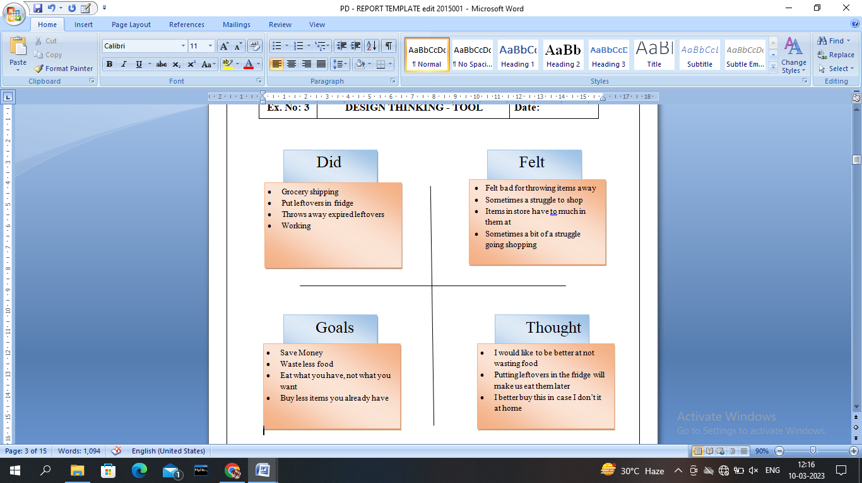

Figure 3.1 Empathy Map

## CUSTOMER JOURNEY MAP

A customer journey map is a very simple idea. It is a diagram that illustrates the steps what customers go through in engaging with a company, whether it be a product, an online experience, retail experience, or a service, or any combination. The more touch points the company have, the more complicated but necessary such a map becomes. Sometimes customer journey maps are “cradle to grave,” looking at the entire arc of engagement.

| **Stage of the Journey** | **Customer Actions** | **Emotions** | **Business Actions** |
| --- | --- | --- | --- |
| Awareness | Becomes aware of the issue of food waste | Concerned about the environmental impact of food waste | Provides educational materials on food waste reduction, promotes  food waste reduction initiatives on social media and in-store signage |
| Consideration | Considers how to reduce their own food waste | Motivated to take action, but may feel overwhelmed | Offers tips and resources for reducing food waste at home, provides recipe ideas for using up leftover ingredients |
| Purchase | Shops for food with an eye toward reducing waste | Hopeful about making a positive impact, but may find it challenging to avoid waste | Provides products that can help reduce food waste, such as reusable containers or smaller portion sizes |
| Use | Prepares and consumes food with a focus on reducing waste | Satisfied with their efforts to reduce waste, but may struggle with finding ways to use up all food items | Provides cooking and storage tips for reducing waste, offers guidance on using up leftover ingredients |
| Disposal | Disposes of any food waste in a responsible manner | Concerned about the environmental impact of food waste | Provides information on composting and recycling food waste, encourages responsible disposal practices |
| Advocacy | Shares their experience with others and encourages them to reduce food waste | Proud of their efforts and excited to share with others | Encourages customers to spread the word about food waste reduction, offers rewards for referrals or social media shares |

## CHAPTER 4

**FOOD WASTE REDUCTION MANAGEMENT**

Food waste or food loss refers to the [food](https://en.wikipedia.org/wiki/Food) that is spoilt, lost or uneaten. The causes of food loss occur very often because of the mismanagement of producing, processing, and vending of the food. Every year an estimated 1.3 billion of food is wasted globally and one-third of food produced for human consumption. Wastage occurs at all stages of the food supply chain. A huge amount of wastage happens at the time of production in the poor countries whereas a large amount of food (around 100 kilograms) for each person per year is wasted in the consumption period in developed countries. Bangladesh is a highly populated country although it has an emerging economy approximately 49% of its population is still being lived below the poverty level. Food waste is one of the emerging threats to the food security of the country. In Bangladesh, nearly 5.5% of the total procured food is being wasted by a person at the time of eating daily. Besides this, a large proportion (52%) of food is waste during different occasions like marriage ceremonies,birthday,parties,etc.

## ARCHITECTURE DIAGRAM USE CASE DIAGRAM

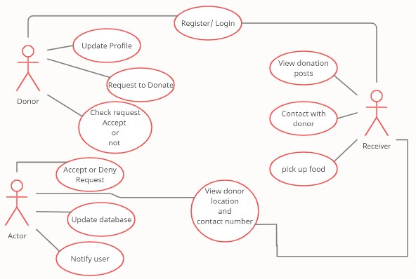

Fig 4.1 Use case diagram for both User and Admin

**SEQUENCE DIAGRAM**

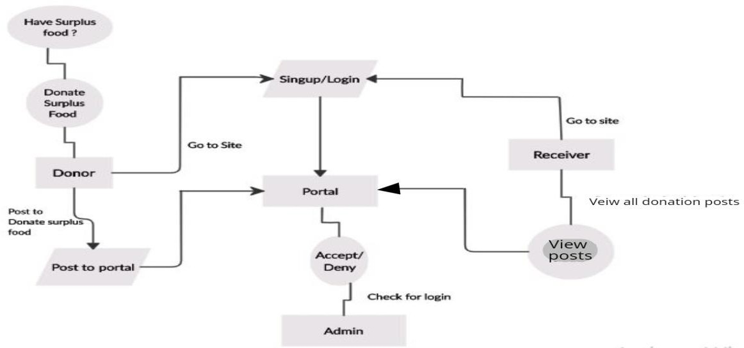

Figure 4.2 sequence diagram for both user and admin

## MODULES

In the Food Waste Reduction Management there are six modules which are listed below,

**User Module:**

* Sponsor details
* Employee Details
* Food Donation
* Orphanage details
* Feedback
* Reports

**4.2.1 MODULE DESCRIPTION**

**Donor Details:**

The Sponsor details are need to stored into database. This details are follows name, age, gender, mobile number ,email id and address. This sponsor details are also includes modify their details like update and delete. Admin can manage the sponsor details.

**Employee Details:**

The employee details are maintain by the admin. The employee details are like name, qualification, work details and their contact details.

**Food Donation:**

The sponsor can donate food via this application. The food donation contains sponsor name, Date, Session and food details. Admin regularly monitor the food sponsor details and communicate to the sponsors.

**Orphanage details:**

Admin can store and manage the orphanage details. The orphanage details contains orphanage name, Manage Name and contact details.

12

**Feedback:**

If the donors wants to tell any suggestion about the service, then the user will freely notify their opinion to administrator. This module will directly monitored by the admin.

**Records:**

All the details are regularly stored into the database. The reports are like member report, donation report. The record maintained is very much user friendly.

13

## CHAPTER 5 SYSTEM REQUIREMENTS

## SOFTWARE REQUIREMENTS

OPERATING SYSTEM : Windows 10

FRONT END : ASP.NET 2010

BACK END : MS Access 2007

## FRONT END

**ASP.NET (Active Server Pages)**

ASP.NET is a technology used for creating Web applications and Web services that are executed in the IIS server. The ASP.NET pages are compiled making the application faster that classic ASP. It provides good level of consistency over the web applications. It has a large set of user controls, XML based components and user authentication.

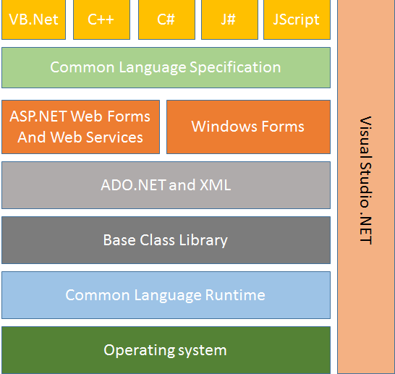

Figure 5.1 ASP.NET framework

Here various components of the ASP.NET framework and their features are mentioned below:

**1. Common Language Runtime:**

The Common Language Runtime (CLR) is used as execution engine for .NET framework. All the ASP.NET code is executed in the CLR. It performs functions like security, memory management, exception handling, thread execution, code verification, code security. The Just In time compiler is used for compilation of the ASP.NET code.

The source is compiled into the intermediate language code. The JIT compiler coverts the IL code into native code that is specific to the system.

**2. Base Class Library:**

The Base Class Library is the functionality available to all the .NET framework languages. It provides various features like database connectivity, XML document manipulation, classes and interfaces that are reusable with the CLR.

**3. ADO.NET and XML:**

ADO.NET is used for the database operations in .NET. It works efficiently with SQL Server, OLEDB, XML. The operations like accessing data from the data source, updating and manipulating data are performed through ADO.NET. Extensible Markup Language (XML) is useful for designing the web pages in .NET

**4. Windows Forms:**

The windows Forms application is used for creating window application in .NET. There are wide controls and designing features available for Windows Forms.

**5. ASP.NET Web Forms and Services:**

The Web Forms user to create Web based applications. They include web pages and several GUI components for designing. It helps simultaneous addition of

15

controls at runtime and design time. Web Services are used when the user needs specific task to be executed. They are used for creating single application or distributed on the web.

**6. Common Language Specification:**

The Common Language Specification (CLS) is a set of language features used for developing web application and web services. It ensures interoperability among applications without the language dependency. It defines a subset of Common Type System (CTS) providing objects of different languages to interact with each other.

**7. Visual Studio .NET:**

The Visual Studio .NET is used for developing all the web and windows applications. The GUI interface and extensive built in class libraries are provided in the component. Web Services can be developed and deployed using Visual Studio.

16

## BACK END

## MICROSOFT ACCESS

Microsoft Access is a well-known database management system produced by Microsoft and is part of the Microsoft 365 office suite. Microsoft Access combines Microsoft’s relational Jet Database Engine with software development tools and a graphic user interface (GUI). It was first released in November 1992, so it’s been around for a while. Microsoft Access also has the distinction of being the first mass-market database program for Windows.

Microsoft Access enables business and enterprise users to manage data and analyze vast amounts of information efficiently. The program provides a blend of database functionality and programming capabilities for creating easy-to-navigate forms. Microsoft Access is like Microsoft Excel in that you can store, edit, and view data.

**How Microsoft Access is Used**

Here are some of Microsoft Access’s most-used features:

* Importing data from Excel or other databases
* Creating forms for data entry or viewing
* Designing and running data retrieval queries
* Designing reports to be either printed or turned into a PDF
* Allowing users to interact with Access via SQL

**The Components of Microsoft Access**

Microsoft Access is composed of the following components:

* Tables: Access stores its data in tables, using a row and column format. Users can create one database that includes all the data of one project. This database is known as a “flat” database. More on databases later.
* Relational Databases: Although users can place a project's data in just one

17

* database, it's typically easier to create numerous tables dedicated to a different aspect of the project. Fortunately, each table can be connected and interrelated, an arrangement known as a relational database.
* Forms: Forms enable users to enter data into the database without relying on a spreadsheet.
* Macros: Macros are small programming constructs consisting of commands and processes and are a huge time saver.
* Modules. Modules are procedures, also called functions, which users can write with Visual Basic Applications.
* Queries: Queries find information in databases, a helpful tool, considering the size of many Access databases.
* Reports: Reports simplify the processes of sorting, labeling, summarizing, and grouping data to easily share or print.

**The Uses of Microsoft Access**

Over the last three decades, Microsoft Access has repeatedly shown its versatility. Microsoft Access can:

* Store data in table form, which can be later edited or customized to the user’s needs
* Manage bills and accounts
* Compare data or find common relationships between existing data
* Create database websites
* Develop applications suitable for small businesses, departments within a corporation, or personal use

18

## DATABASE

**The Microsoft Access Database**

Microsoft Access consists of two distinct types of databases:

* First, flat file databases store data in plain text files and can't incorporate multiple tables.
* Secondly, relational databases store data in forms that relate to each other. For example, relational databases support multiple tables, which arrange the text into columns and rows.
* Attachment: Stores files like digital images
* Auto Number: Either assigned by Access or the user when a new record is created
* Calculated: Creates an expression that uses data from one or multiple fields
* Currency: Stores currency values and numeric data featuring one to four decimal places
* Date/Time: Stores date and time information for a year range between 100 and 9999
* Hyperlink: Stores a combination of numbers and text, used as a hyperlink address
* Long Text: Typically used for lengthy alphanumeric or text data, up to 63,999 characters
* Numbers: Numeric data used for storing mathematical calculations
* OLE Objects: This data encompasses audio, video, and other Binary Large Objects
* Short Text: Stores text and numbers not used in calculations
* Yes/No: Only stores the logical values of Yes and No

19

**The Benefits of Microsoft Access**

Microsoft Access brings many advantages to the table, including:

* It gives users a fully functional, relational database management system in minutes
* It’s easy to import data from multiple sources
* It’s easily customized to fit any personal or company needs
* The online Microsoft Access works nicely with many development languages that work on the Windows operating system
* It’s a robust and flexible utility that can perform any demanding office or industrial database task
* MS-Access lets users link to data in its current location and use the information for viewing, querying, updating, and reporting
* It’s simple to install and easy to understand
* It lets users create tables, forms, queries, and reports and connect with the aid of Macros
* Macros in Access are simple programming constructs that helps users add functionality to their database
* The graphical user interface (GUI) helps simplify its use
* Microsoft Access online are able to perform heterogeneous joins between many data sets that are stored across various platforms

20

**The Drawbacks of Microsoft Access**

Of course, no application is perfect. Every product has its downside, and Microsoft Access is no exception. Its drawbacks include:

* If too many users attempt to gain access to the same database at once, this may negatively impact the speed and efficiency. There is an apparent limit to how many people can simultaneously work on the same database.
* Related to the first point, the Microsoft Access database is more beneficial for small-to-medium businesses but not as much for large-sized organizations.
* There are better database systems available when working with confidential data.
* Microsoft Access lacks the robustness found in other DBMS systems such as MS SQL Server or Oracle.
* Since all the information from a database is saved into one file, this can slow down reports, queries, and forms.
* Although the technical limit is 255 concurrent users, the real-world limit actually ranges from only 10 to 80, depending on the kind of application the organization is currently running.
* Microsoft Access requires considerably more learning and training when compared with other Microsoft programs.

21

## CHAPTER 6 IMPLEMENTATION AND RESULT

**Implementation**

**Visual Studio**

Visual Studio includes a [code editor](https://en.wikipedia.org/wiki/Code_editor) supporting [IntelliSense](https://en.wikipedia.org/wiki/IntelliSense) (the [code completion](https://en.wikipedia.org/wiki/Code_completion) component) as well as [code refactoring](https://en.wikipedia.org/wiki/Code_refactoring). The integrated debugger works as both a source-level debugger and as a machine-level debugger. Other built-in tools include a [code profiler](https://en.wikipedia.org/wiki/Profiling_(computer_programming)), designer for building [GUI](https://en.wikipedia.org/wiki/GUI) applications, [web designer](https://en.wikipedia.org/wiki/Web_designer), [class](https://en.wikipedia.org/wiki/Class_(computing)) designer, and [database schema](https://en.wikipedia.org/wiki/Database_schema) designer.

Visual Studio includes a [code editor](https://en.wikipedia.org/wiki/Code_editor) that supports [syntax highlighting](https://en.wikipedia.org/wiki/Syntax_highlighting) and [code completion](https://en.wikipedia.org/wiki/Autocomplete) using [IntelliSense](https://en.wikipedia.org/wiki/IntelliSense) for [variables](https://en.wikipedia.org/wiki/Variable_(programming)), [functions](https://en.wikipedia.org/wiki/Subroutine), [methods](https://en.wikipedia.org/wiki/Method_(computer_science)), [loops](https://en.wikipedia.org/wiki/Program_loops), and [LINQ](https://en.wikipedia.org/wiki/LINQ) queries. IntelliSense is supported for the included languages, as well as for [XML](https://en.wikipedia.org/wiki/XML), [Cascading Style Sheets](https://en.wikipedia.org/wiki/Cascading_Style_Sheets), and [JavaScript](https://en.wikipedia.org/wiki/JavaScript) when developing web sites and [web applications](https://en.wikipedia.org/wiki/Web_application). Autocomplete suggestions appear in a [modeless](https://en.wikipedia.org/wiki/Modeless) [list box](https://en.wikipedia.org/wiki/List_box) over the code editor window, in proximity of the editing [cursor](https://en.wikipedia.org/wiki/Cursor_(computing)). In Visual Studio 2008 onwards, it can be made temporarily semi-transparent to see the code obstructed by it. The code editor is used for all supported languages.

To start writing ember apps type command “ember new my-app”, this will create a directory in the name of ‘my-app’, which will have the basic structure of an ember app development environment.

The Visual Studio interface is represented in the Figure 6.1.

22

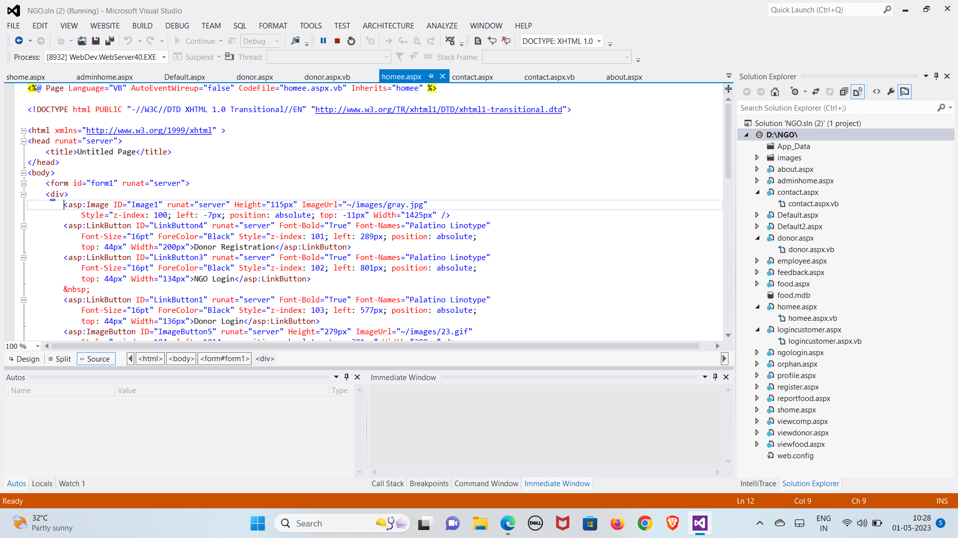

Figure 6.1 Visual Studio

## Experimental Result

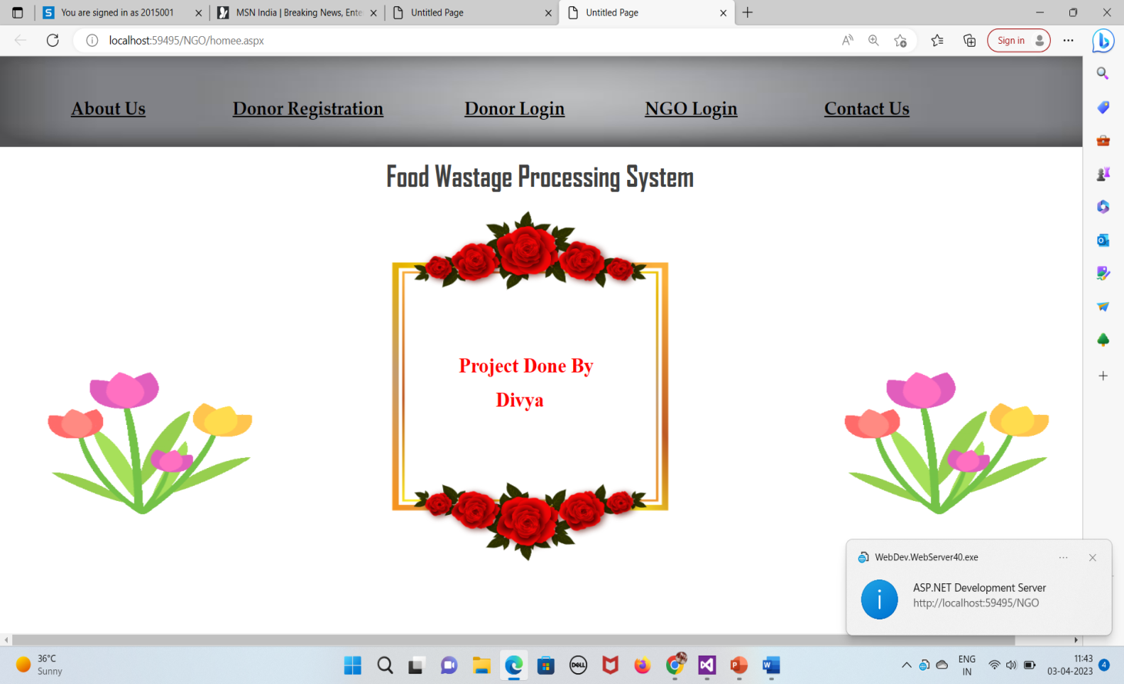

Figure 6.2 Home page

The figure 6.2 shows the interface of food waste reduction management homepage.

23

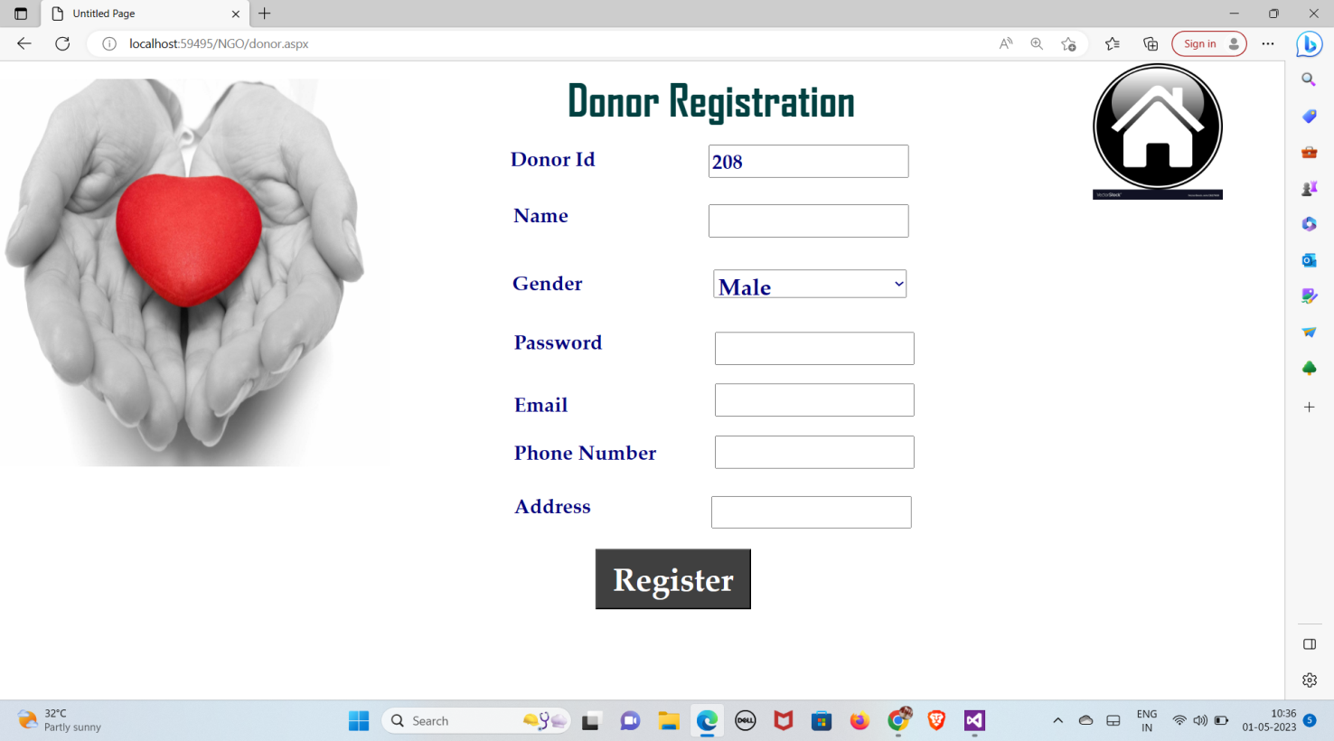

Figure 6.3 Donor Registration page

The figure 6.3 shows user registration. Only admin participants can register using this page.

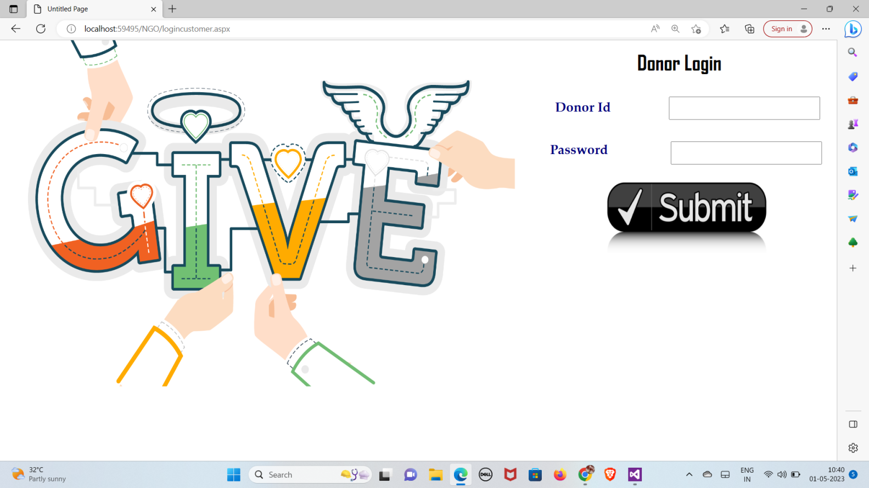

Figure 6.4 Donor Login Page

The figure 6.4 shows Donor login he/she registered

24

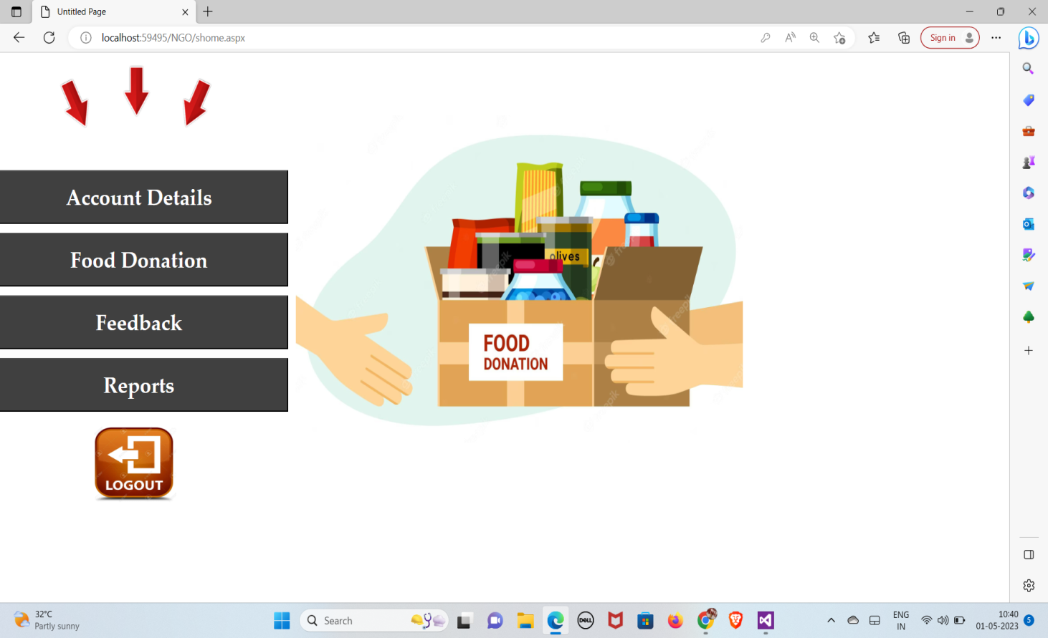

Figure 6.5 Donor Home Page

The above figure 6.5 shows the Donor Home page using username and password

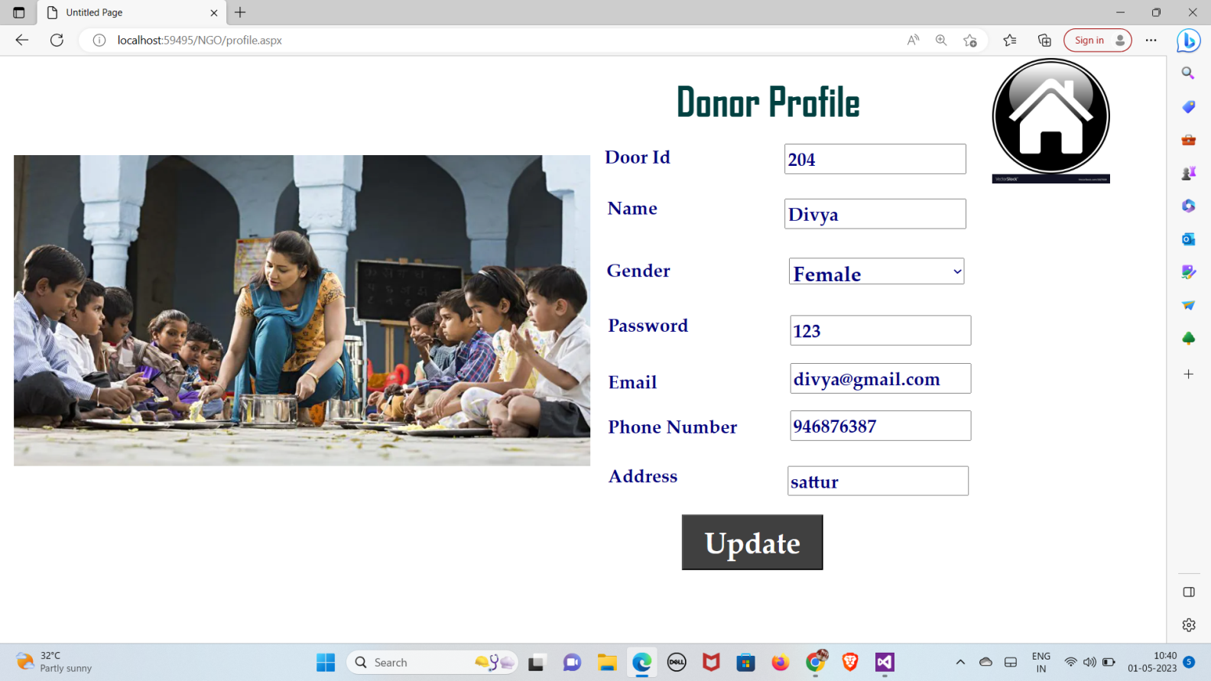

Figure 6.6 Donor Profile Page

The above figure 6.6 shows the Donor profile page he/she can any time update their profile.

25

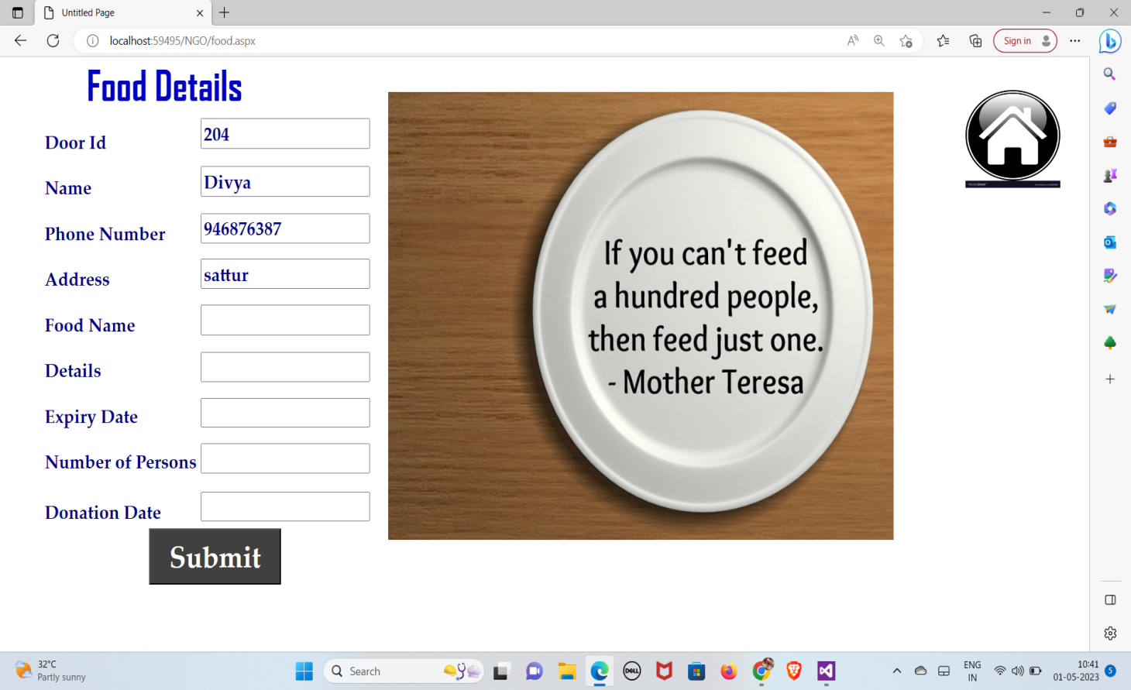

Figure 6.7 Donor Food Details

The figure 6.7 shows the Donor details and Food details. The NGO can view the Donor details.

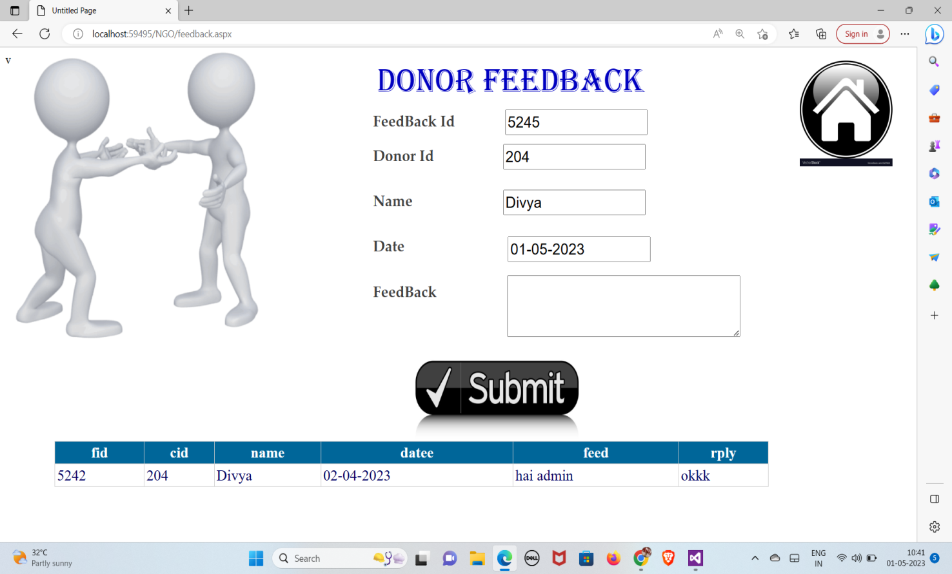

Figure 6.8 Donor FeedBack Page

The figure 6.8 shows the donor feedback page he/she donor can give their feedback to the NGO and donor can view NGO replies.

26

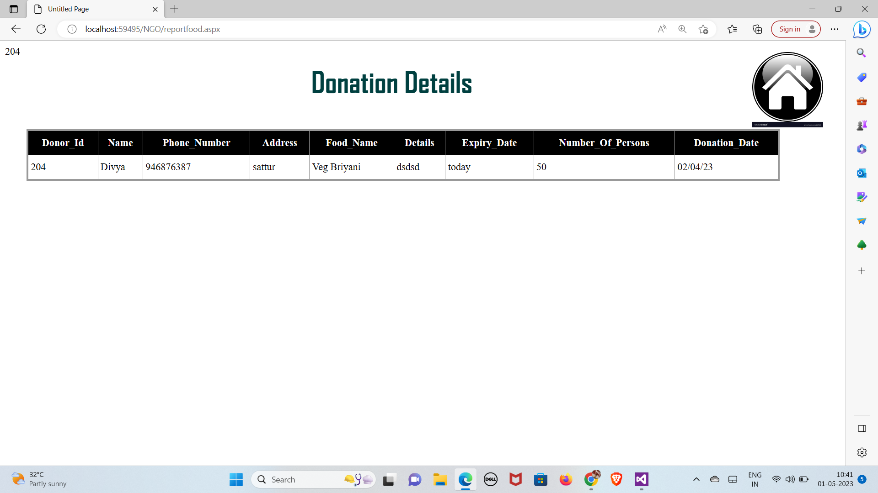

Figure 6.9 Donor Details

The above figure 6.9 shows how many participants can registered and donate their foods.

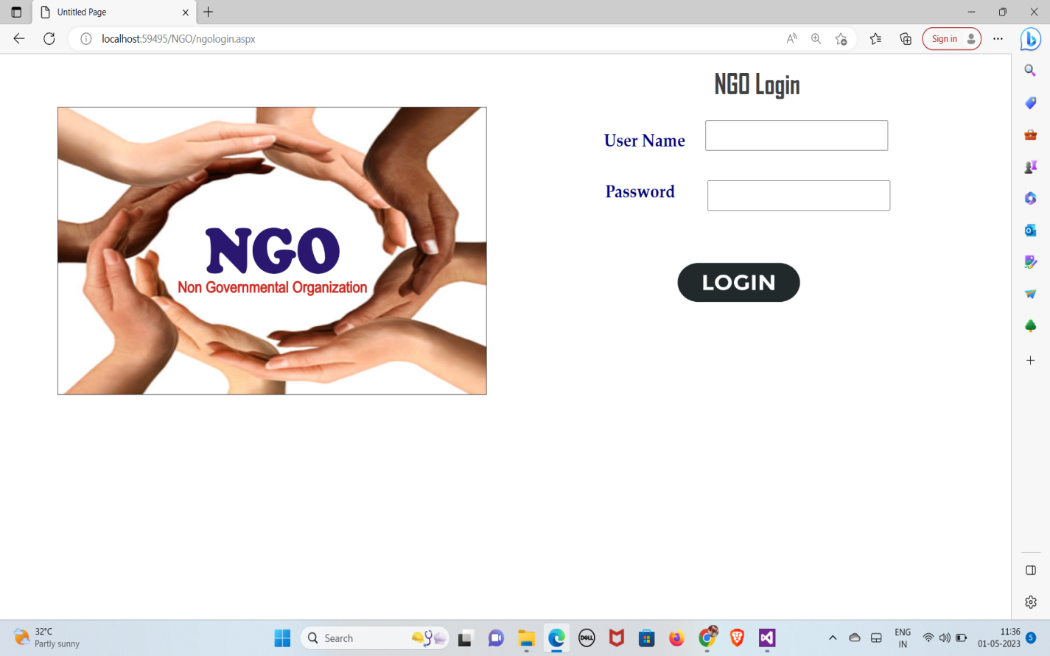

Figure 6.10 NGO Login Page

The above figure 6.10 shows the NGO admin Login page.

27

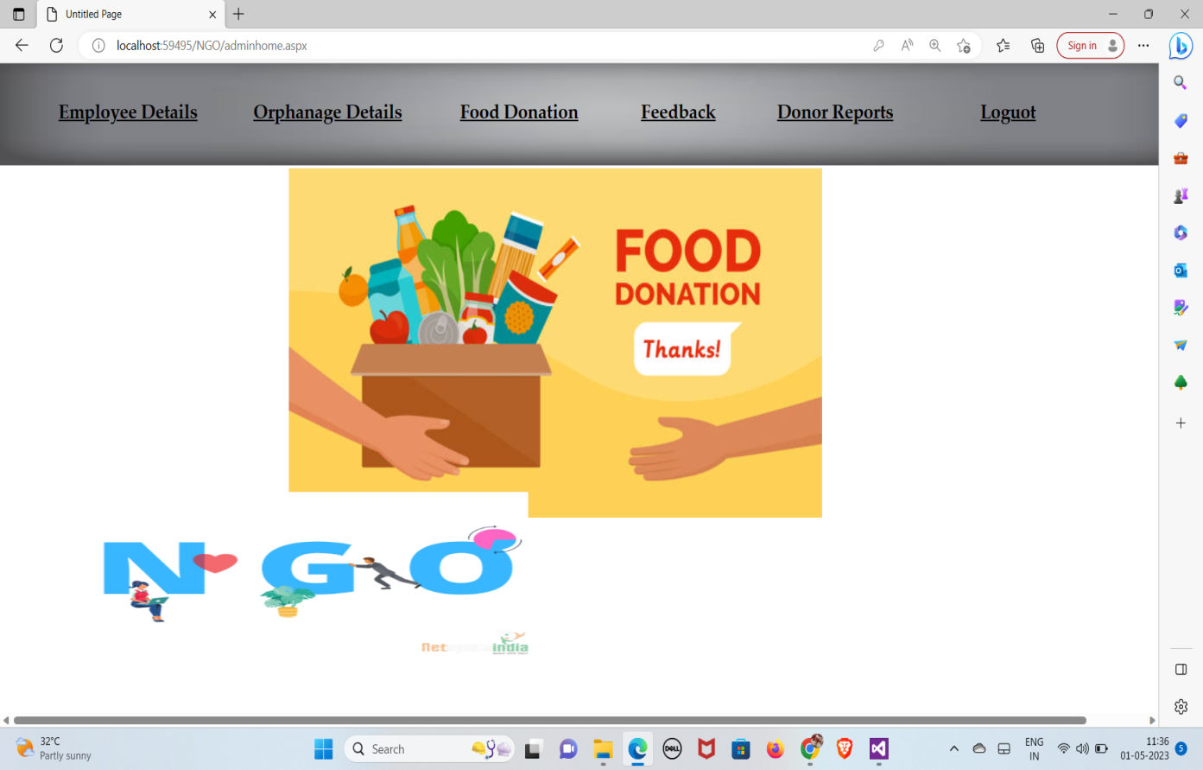

Figure 6.11 NGO Home Page

The above figure 6.11 shows the NGO admin home page.

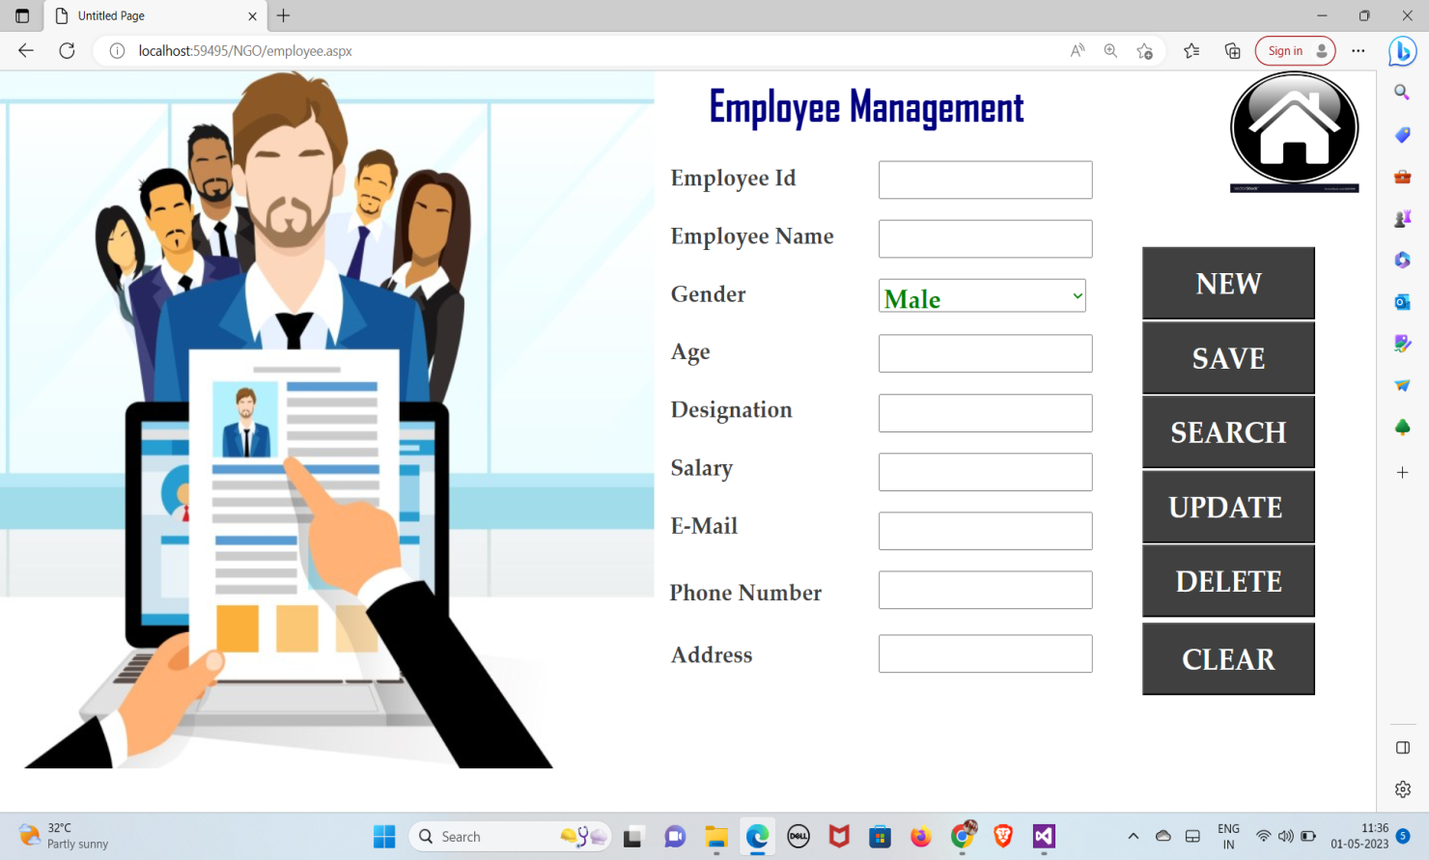

Figure 6.12 Employee Management Page

The above figure 6.12 shows the Employee Management page, the NGO can add new employee and save, search, update, delete and clear their details.

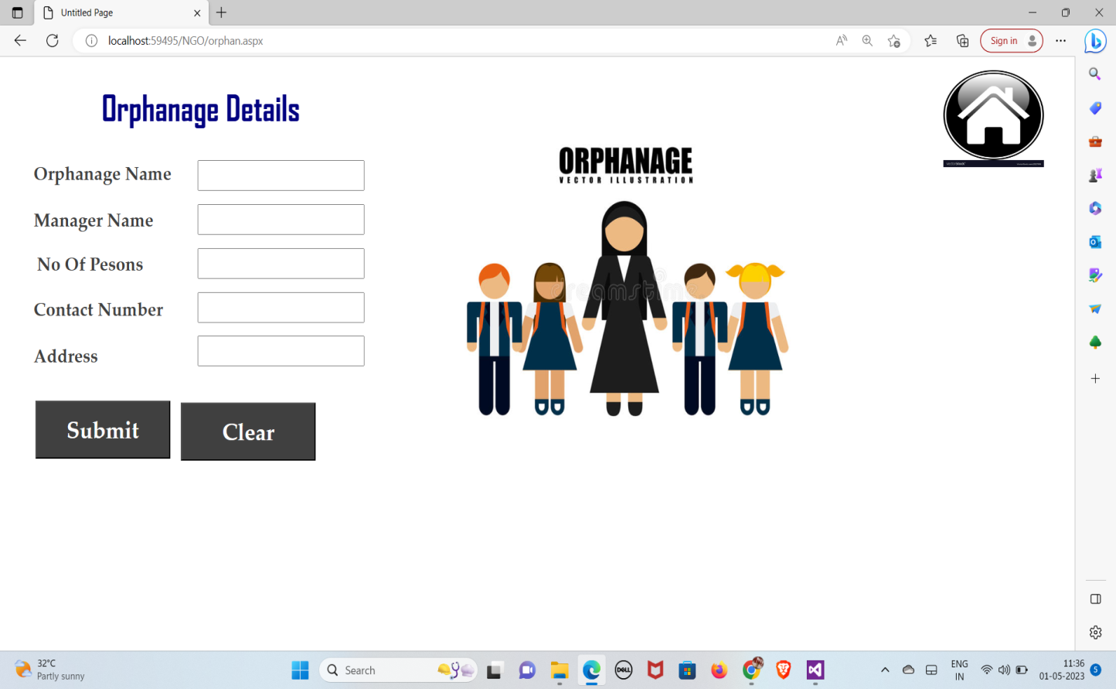

Figure 6.13 Orphanage Details Page

The above figure 6.13 shows the Orphanage Details page only can view NGO admin.

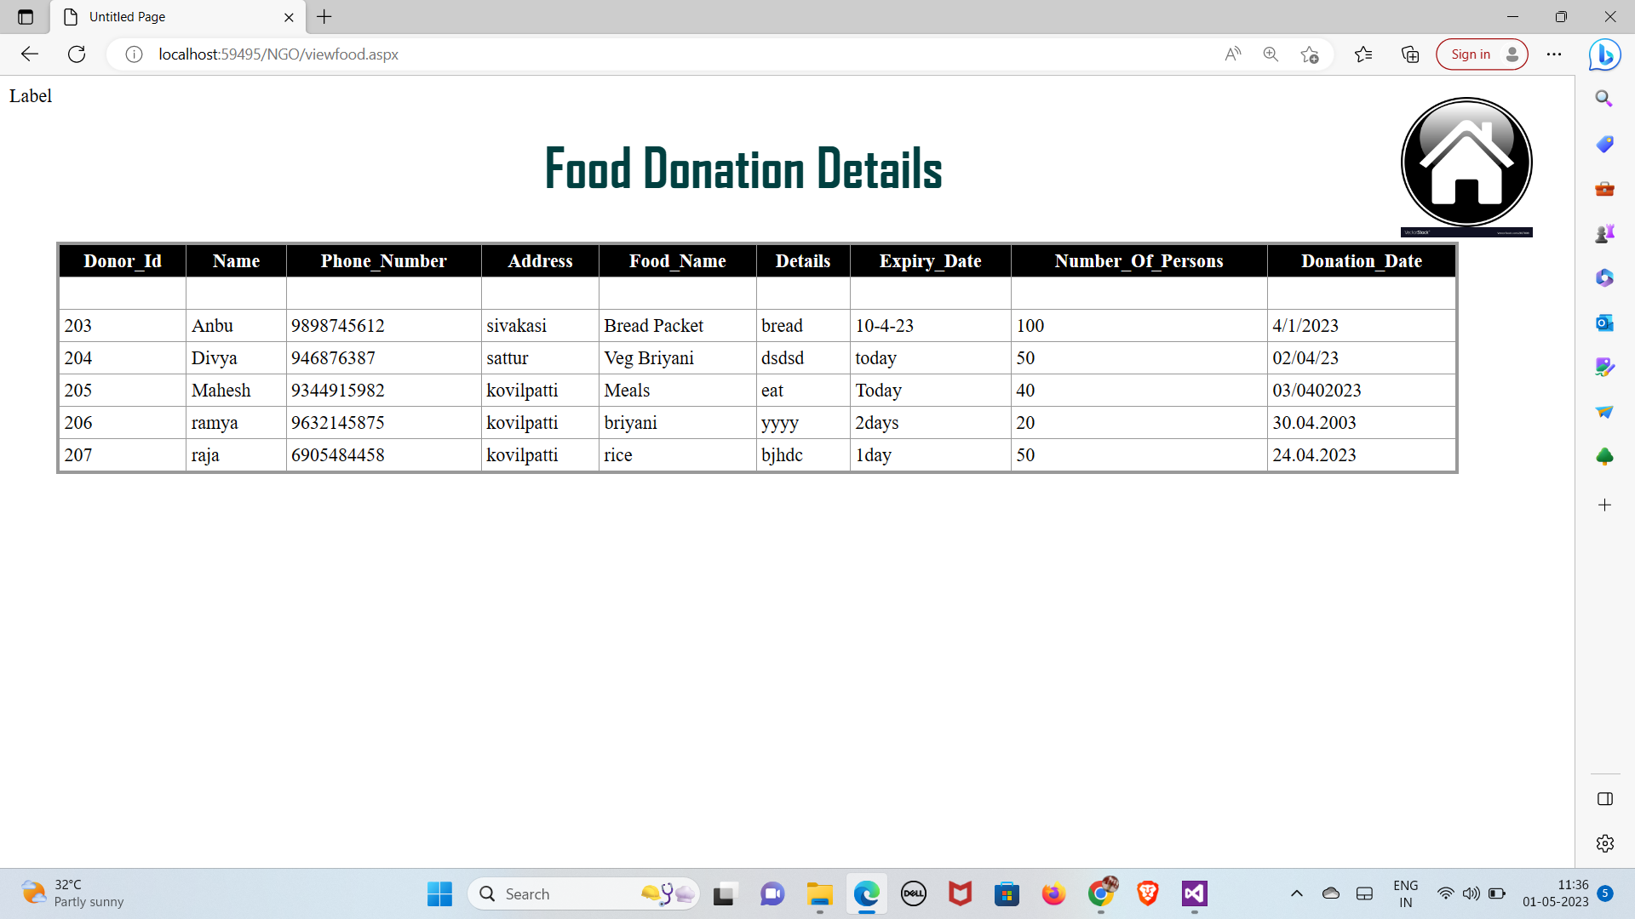

Figure 6.14 Food Donation Details Page

The above figure 6.14 shows the Food donation details page only can view NGO admin. 29

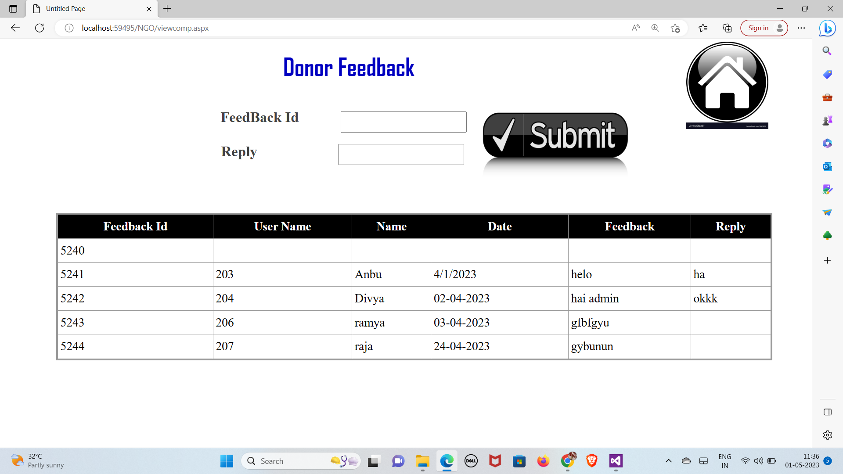

Figure 6.15 Donor Feedback Page

The above figure 6.15 shows the donor feedback page , the NGO can view and reply to the individual donors.

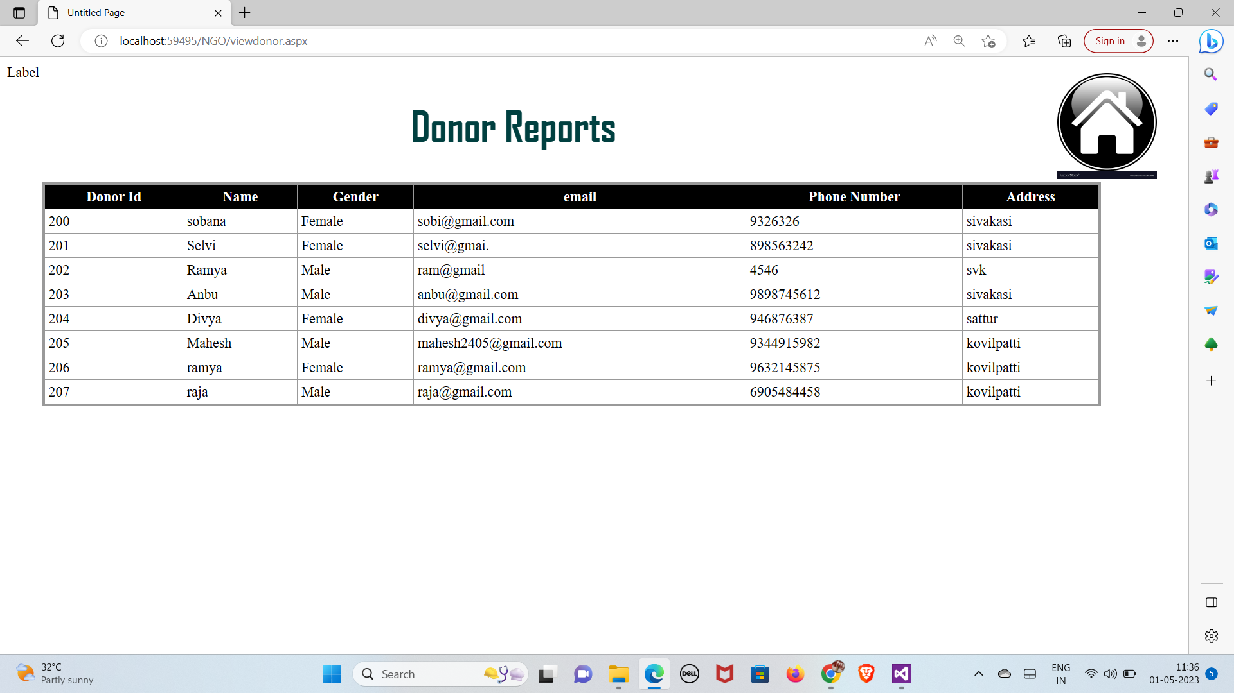

Figure 6.16 Donor Reports Page

The above figure 6.16 shows the donor reports page, the NGO can view the hole donors. 30

## CHAPTER 7 CONCLUSION AND FUTURE SCOPE

**CONCLUSION**

The proposed project entitled as “Food waste reduction management” will fulfill the entire information and transaction requirements by the user. The proposed software is developed as per the requirements given. All the activities are related with process planning and we can change the requirements any time. So whenever changes are required, the application can be modified. The project has been tested with the required data is working satisfaction.

It saves normal human works and makers’ execution faster and computation results in getting the reports with high degree of accuracy. I completed my project successfully with help of our guide in a short time.

## FUTURE ENHANCEMENTS

* Smart Technology: The use of smart technology such as sensors and software can help businesses and individuals monitor food waste in real-time, helping to identify areas where waste can be reduced. Smart refrigerators can keep track of expiration dates and send notifications when food is about to expire.
* Food Recovery Programs: Food recovery programs can be expanded to help reduce waste. For example, businesses can partner with food banks and other organizations to donate excess food that is still safe to consume but is not needed. Similarly, individual households can donate excess food to local food banks.

31

# Composting: Composting is a great way to reduce food waste by converting it into a valuable resource. Businesses and individuals can compost food scraps and use the resulting compost to enrich soil for gardening and agriculture.

# Food Waste Audits: Conducting regular food waste audits can help businesses identify areas where waste can be reduced. These audits can help businesses to identify the types of food that are being wasted, the reasons for the waste, and potential solutions to reduce waste.

# Collaboration and Partnerships: Collaboration and partnerships between businesses, governments, and non-profit organizations can help to drive innovation and share best practices in food waste reduction management. This can include sharing data and insights, developing new technologies and solutions, and creating awareness campaigns.

# 32

# REFERENCES

**Websites**

* https://www.tutorialspoint.com/asp.net/index.htm
* https://www.w3schools.com/asp/
* https://dotnet.microsoft.com/en-us/learn/aspnet
* https://www.tutorialsteacher.com/core
* https://stackify.com/learn-asp-net-tutorials/
* https://asp.net-tutorials.com/
* https://www.dotnettricks.com/learn/aspnet
* https://asp.net-tutorials.com/
* https://www.pragimtech.com/courses/asp-net-tutorial-for-beginners/

**Books**

* Programming ASP.NET MVC 4: Developing Real-World Web Applications with ASP.NET MVC (2nd Edition) - Author Hrusikesh Panda Publication: Bhasin
* Pro ASP.NET Core 6: Develop Cloud-Ready Web Applications Using MVC, (1st Edition) - Author Bhasin Blazor, and Razor Publication: Hendry
* Beginning ASP.NET for Visual Studio 2015 (2nd Edition) - Author Markov Yansen Publication: Star
* ASP.NET Core 5 for Beginners: (4th Edition) - Author Andreas Helland, Publication: Google Books

33

* C# 9 and .NET 5 - Modern Cross-Platform Development Asp.Net: The Complete Reference (1st Edition) - Author Mark J. Price Publication: Bhasin
* ASP.NET Core Recipes: A Problem-Solution Approach (1st Edition) – Author John Ciliberti Publication: Google Books.

34